**Past Life Astrology**

[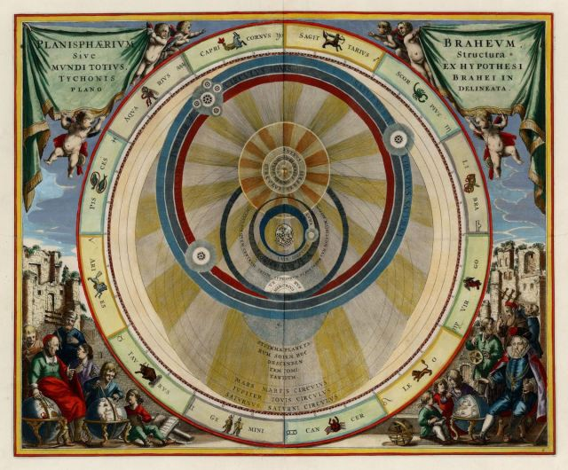](https://benebellwen.com/wp-content/uploads/2022/10/the-planisphere-of-brahe-andreas-cellarius-1660.jpg)The Planisphere of Brahe, Andreas Cellarius (1660s)

I am open to the concept of reincarnation. While I believe we have many past lives, my approach to past life astrology analysis is based on a native’s present life natal chart.

The way I read the chart, it yields the one past life that is most influential on the present life karma. What is in your subconscious now, your inclinations, and innate abilities are based on the experiences of this particular past life and it is only through the balancing and reconciliation of the karma from this past life incarnation that you will be able to move on completely from the tethers of your past life karma.

**The Moon and Who You Once Were**

In past life astrology, I focus on the moon, in part because the moon represents our subconscious and latent memories. It represents facets of spirit remnant from another time, and thus reveal where we come from. It is the first link I consider in a past life reading. All aspects of your natal moon’s correspondences and positioning are considered, house and sign of course, the aspects, and conjunctions. The moon gives me the character profile.

The moon is the first gateway into your subconscious, and from there we can connect further into the personal unconscious, where we hope to retrieve information about your past life identity.

**The South Lunar Node and Karmic Baggage**

The southern node is considered for determining karmic remnants from the past life that must now be accounted for in the present life. From the southern node, I try to glean what might have been repressed in the present life due to what was left unaddressed or unaccounted for in the past life.

In both the northern and southern nodes, we can get a sense of destiny, of abilities and accomplishments that have been passed on from one lifetime into another.

What’s close by to your south lunar node? What are some of the key angular aspects that your south node is tied to? Considerations of the south node, at least for me as an astrologer, are a merger of shadow work and past life analysis. We’ll also see aspects of the inner child, which were influenced by your past life.

**The Fourth House: The Karma That Paved Your Childhood**

House 4 gives us insight into specific memories that are of particular importance to the karma of the present life. It connects the past life with your present life childhood.

The fourth house is the house of your soul. In traditional astrology, the fourth house is read for two different life components that seem to contradict. Fourteenth and fifteenth century astrologers have talked about the fourth house as indicative of childhood, home, and the social status and family you are to be born into; yet they also talk about the fourth house as indicative of end of life, mystical matters, and your soul’s connection to what is beyond the dark veil. It is one of the houses to consider when seeking occult inquiries.

I don’t see this dual interpretative approach as contradictory at all. Instead, I see it as many voices trying to articulate one thing—that perhaps fourth house activities have some bearing on the journey of our soul, and therefore can shed insight into our previous lifetimes. It relates to our karmic account, and the karma we bring into this current life.

As I’ve noted earlier, aspects of your past life and soul purpose can be found here, as with matters relating to your roots and heritage. The fourth house is directly related to your tenth house, toward your higher purpose, glory, and professional potential, and so childhood experiences (also past life experiences), as expressed here in the fourth house determine the career trajectory you take through life and future social status, as expressed in your tenth house.

**The Eighth House: Transformation and Rebirth**

The next house, also traditionally related to occult and mystical matters, is the eighth house. The eighth house, traditionally referred to as the house of death and rebirth, but also of the estates we inherit, can shed light on that nexus or connecting point between our past life incarnation and present life. It can reveal that one point where the past ended and the present began. It is therefore the house of death and rebirth.

Think of your natal chart as not one layer but many layers superimposed over one another. In other words, the moon, fourth house, and eighth house bear one meaning when we examine the chart for your current lifetime and your personality right now, because when we look at your chart specifically for those issues, we are examining just one layer. If we’re looking at the natal chart and transits or progressions, we are examining the same exact chart, but looking at a different layer.

In past life astrology, we are looking at the often unseen implications of the celestial activity in your chart. The eighth house in a chart can reveal what aspects of a past trickle into your present as ongoing karmic lessons you need to confront, defeat, and move on from.

**The Twelfth House: Trials and the Hidden Self**

House 12 shows the personal trials experienced in the past life that have a karmic impact on the present life.

The twelfth house in straightforward natal astrology is typically read to indicate some of the major hurdles you might face in your lifetime, obstacles, and personal weaknesses.

In past life astrology, the twelfth house is read to assess karmic debt, or essentially, what baggage you’ve brought into this current life from your past life. Again, we are looking at only one specific past life incarnation, the one that seems to most affect the karma of your current life. It is the one past life incarnation that seems to have the most unfinished business. And here in the twelfth house, we examine what that unfinished business is.

**Why Past Life Astrology**

I offer past life astrology readings and have found them to be fruitful, whether you believe in reincarnation or not. It offers a fascinating narrative to study and to think about how that narrative might relate to your present life circumstances, and more pertinently, might explain your present life circumstances. If nothing more, it is a unique story–one I contend is yours alone–where the ending is your life’s beginning.

line

[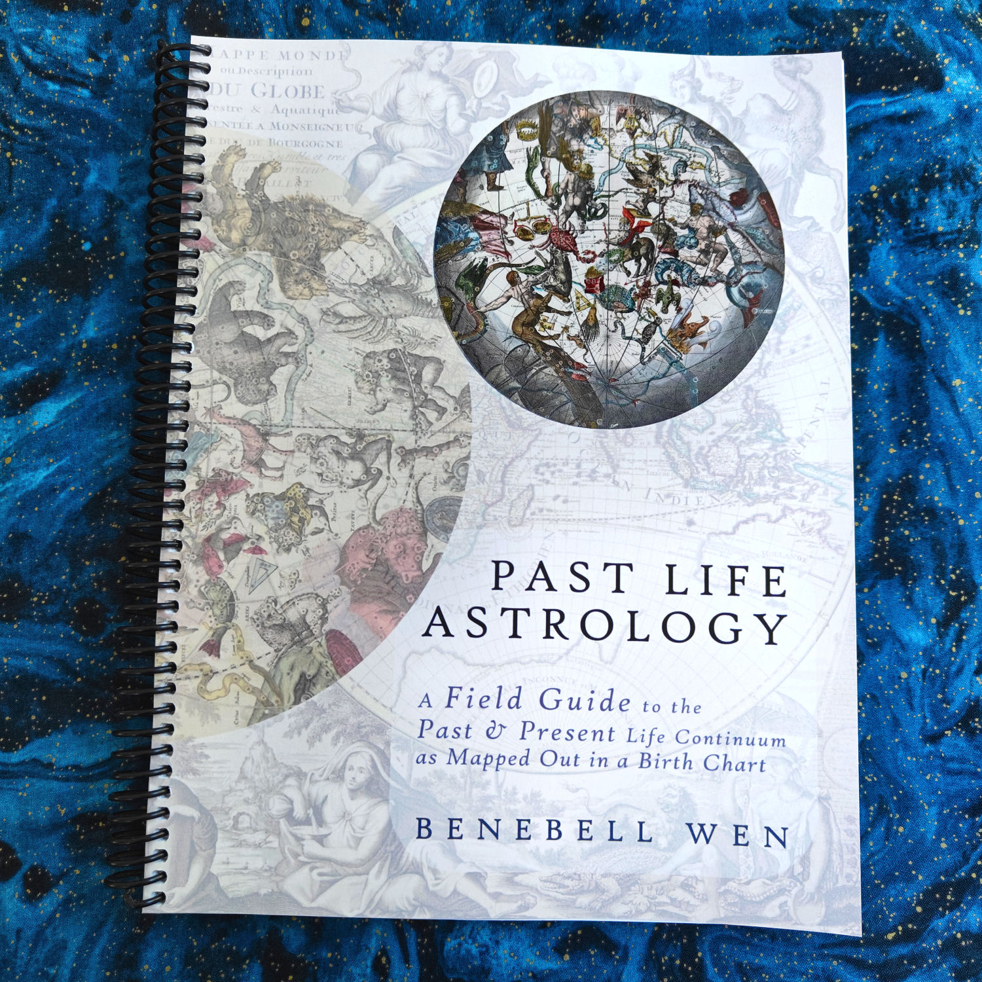](https://benebellwen.com/2024/11/15/introduction-to-past-life-astrology/)

[**Introduction to Past Life Astrology**](https://benebellwen.com/2024/11/15/introduction-to-past-life-astrology/)

This is an independent study course that delves into reading a birth chart for past life and karmic insights, to explore soul patterns through natal astrology. For more information, click on the hyperlinked title above.